Sprint 1

Asia S, Whitley A, Erin A, Jordan M.

**“Our goal is to create a page that seamlessly gives back to Ingrid and her clients.”**

**Deliverables**

**A.)**

* **History & Description**: Ingrid’s Alterations officially became an LLC on March 9th, 2023. The years leading up to that, her business was still the same, just not yet official. She started doing alterations for friends and family and word quickly spread. Now, she has customers driving from across the state and even some flying from out of state. Her seamstress history goes way back to when she first started as an apprentice at age 16. She worked for a fashion company in Italy, Atelier Di Stimamiglio Laura where she and some other girls made J-Lo’s famous green dress. She worked with top designers for years until moving to the states.
* **Current Environment**: Ingrid currently does everything by hand. She does not have a web page or system to help her keep track of clients or work she has done.
* We chose this particular project because we will be helping a small business owner implement her own system that will save her time and provide information for new clients.
* No problems are observed with the current system because there is none in place.
* **Proposed system objectives and constraints**:
  + Build an online presence (O)
  + Streamline client communication (O)
  + Highlight services offered and portfolio (O)
  + Scheduling system (O)
  + Helpful Links (O)
  + Online payments (O)
  + Updates (C)
  + Budget (C)
  + Client Resistance (C)
  + Replacing previous workflow (C)
* **Expected Benefits**:
  + Enhanced communication
  + Easier booking process
  + Saving time
  + Helpful for clients
  + Improved professional image
* **Problem Analysis**: BPA (Business Process Automation)
* **Initial Context Diagram**:

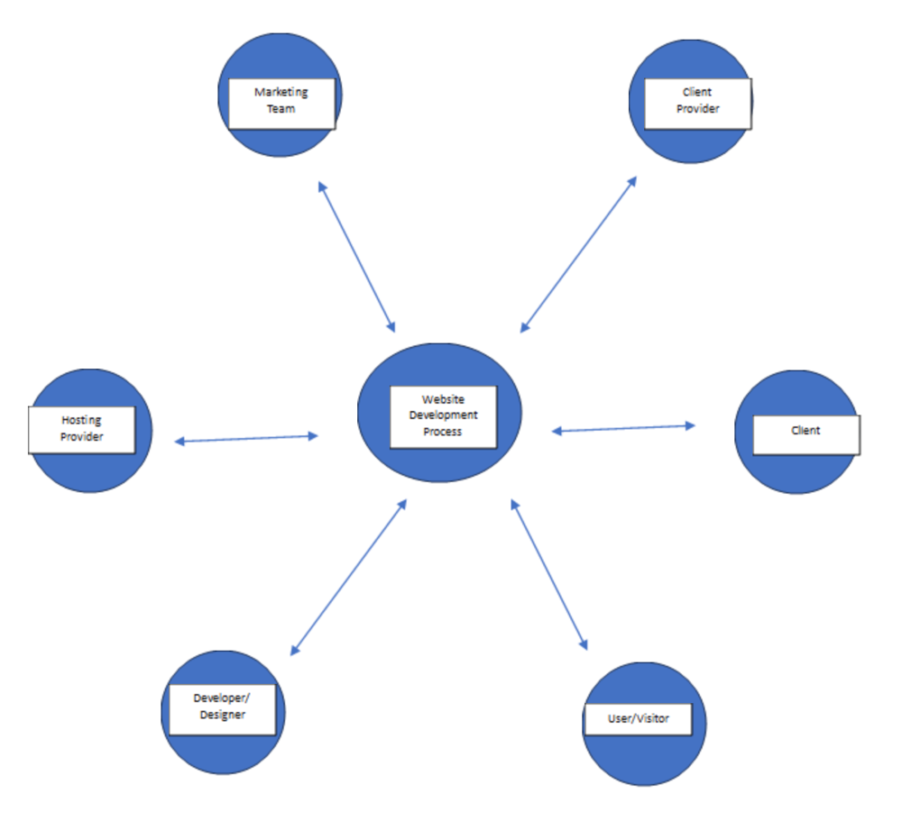

* **Initial Use Case Diagram**: 